# Experiment No: 12

**Aim**

Implementing CRUD operations using PHP-MongoDB

# CO4

Apply CRUD operations and retrieve data in a NoSQL environment.

# Procedure

## connection.php

<?php

require '../vendor/autoload.php';

$con = new MongoDB\Client("mongodb://localhost:27017");

$db = $con->admin;

$collection = $db->registration;

//echo $collection

?>

## registeration.php

<?php

include 'connection.php'; if(isset($_POST['btn'])){

$user=array( 'name'=>$_POST['name1'], 'address'=>$_POST['addrs'], 'Age'=>$_POST['age'],

'Phone'=>$_POST['num'], 'Room type'=>$_POST['room'], 'Room'=>$_POST['acs']

);

$collection->insertOne($user); echo "data inserted"; header("Location:view.php");

}

?>

<html>

<head>

<h2><marquee behavior="scroll" direction="right">Falcon 5 star Hotel</marquee></h2>

<link rel="stylesheet" href="register.css">

</head>

<body>

<form action="#" method="POST">

<table align="center">

<tr>

<th>Name</th>

<td><input type="text" name="name1" placeholder="Full Name"></td>

</tr>

<tr>

<th>Address</th>

<td><input type="text" name="addrs" placeholder="Address"></td>

</tr>

<tr>

<th>Age</th>

<td><input type="text" name="age" placeholder="Age"></td>

</tr>

<tr>

<th>Phone</th>

<td><input type="text" name="num" placeholder="Phone"></td>

</tr>

<tr>

<th>

Room Type

</th>

<td>

<select name="room" id="r">

<option value="Single">Single</option>

<option value="Double">Double</option>

<option value="Dormitory">Dormitory</option>

<option value="Master">Master</option>

</td>

</tr>

<tr>

<th>Room</th>

<td>

<input type="radio" id="ac" name="acs" value="A/C">

<label for="A/C">A/C</label><br>

<input type="radio" id="non" name="acs" value="Non A/C">

<label for="Non A/C">Non A/C</label>

</td>

</tr>

<tr>

<th></th>

<td>

<center>

<input type="submit" name="btn" value="REGISTER">

</center>

</td>

</tr>

</select>

</table>

</form>

</body>

</html>

## View.php

<?php

include 'connection.php';

$result=$collection->find();

?>

<html>

<head>

<title>VIEW</title>

</head>

<body>

<table border="2" >

<tr>

<th>NAME</th>

<th>Address</th>

<th>Age</th>

<th>Phone</th>

<th>Room Type</th>

<th>Room</th>

<th>EDIT</th>

<th>DELETE</th>

</tr>

<?php

foreach ($result as $res)

{

?>

<tr>

<td><?php echo $res['name'];?></td>

<td><?php echo $res['address'];?></td>

<td><?php echo $res['Age'];?></td>

<td><?php echo $res['Phone'];?></td>

<td><?php echo $res['Room type'];?></td>

<td><?php echo $res['Room'];?></td>

<td><a href="<?php echo "edit.php?id=$res[_id]"?>">EDIT</a></td>

<td><a href="<?php echo "delete.php?id=$res[_id]"?>"onclick="return confirm('Are you sure you want to delete?')">DELETE</a></td>

</tr>

<?php

}

?>

<a href="registration.php">Register</a>

</table>

</body>

</html>

## edit.php

<?php

include 'connection.php';

$res = null; // Initialize the variable to avoid undefined variable error if (isset($_GET['id'])) {

$res = $collection->findOne(['_id' => new MongoDB\BSON\ObjectID($_GET['id'])]);

}

if(isset($_POST['update'])){

$collection->updateOne(

['_id' => new MongoDB\BSON\ObjectID($_GET['id'])], ['$set' => [

'name' => $_POST['name1'], 'address' => $_POST['addrs'], 'Age' => $_POST['age'],

'Phone' => $_POST['num'],

'e-mail' => $_POST['mail'], 'Room type' => $_POST['room'], 'Room' => $_POST['acs']

]]

);

echo "Data Updated!!"; header("Location: view.php");

}

?>

<html>

<head>

<title>Register Form</title>

</head>

<body bgcolor="gold">

<h1><center>Update Form</center></h1>

<form method="POST">

<center> Name:

<input type="text" name="name1" value="<?php echo isset($res) ? $res->name : ''; ?>"><br><br> Address <input type="text" name="addrs" value="<?php echo isset($res) ? $res->address : '';

?>"><br><br>

Age <input type="number" name="age" value="<?php echo isset($res) ? $res->Age : ''; ?>"><br><br> Phone <input type="number" name="num" value="<?php echo isset($res) ? $res->Phone : '';

?>"><br><br>

Room Type

<select id="r" name="room"><br><br>

<option value="Single"<?php if(isset($_POST['r']) && $_POST['r'] == 'Single') echo ' selected';

?>>Single</option>

<option value="Double"<?php if(isset($_POST['r']) && $_POST['r'] == 'Double') echo ' selected';

?>>Double</option>

<option value="Dormitory"<?php if(isset($_POST['r']) && $_POST['r'] == 'Dormitory') echo ' selected'; ?>>Dormitory</option>

<option value="Master"<?php if(isset($_POST['r']) && $_POST['r'] == 'Master') echo ' selected';

?>>Master</option>

</select><br><br>

<label for="A/C">A/C</label>

<input type="radio" name="acs" value="<?php echo isset($res) ? $res->Room : ''; ?>"><br><br>

<label for="Non A/C">Non A/C</label>

<input type="radio" name="acs" value="<?php echo isset($res) ? $res->Room : ''; ?>"><br><br>

<input type="submit" name="update" value="Update">

</center>

</form>

</body>

</html>

## Delete.php

<?php

include 'connection.php';

$id=$_GET['id']; echo $id;

$collection->deleteOne(['_id' => new MongoDB\BSON\ObjectID($id)]); header("location:view.php");

?>



**Registration.css**

*{

background: url('img2.jpg'); background-repeat: no-repeat; background-attachment: fixed; background-size: cover;

}

table {

background: url('img1.jpg'); color: white;

}

th {

padding: 8px; text-align: center;

border: 1px solid rgb(79, 71, 164);

}

td {

padding: 8px; text-align: left;

border: 1px solid rgb(79, 71, 164);

}

# Output

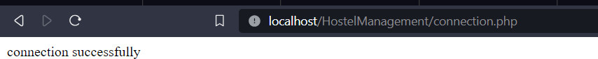

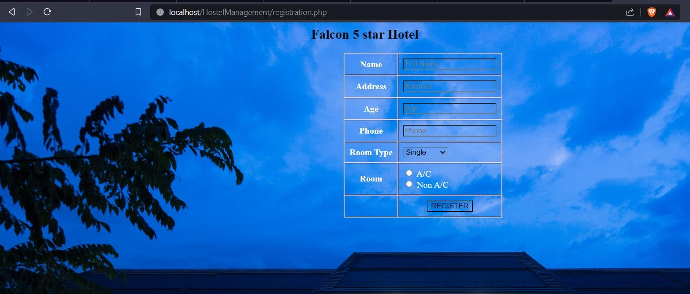

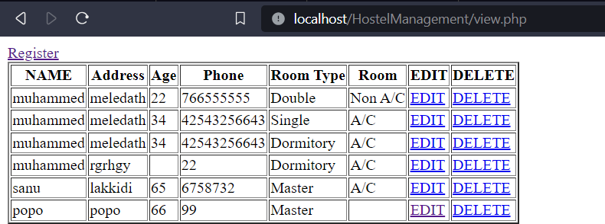

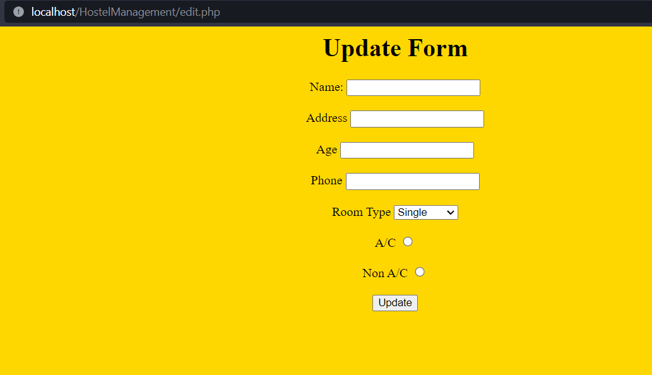

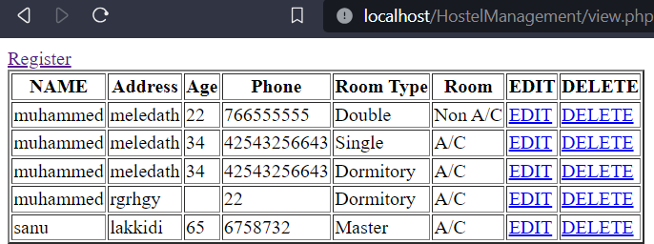

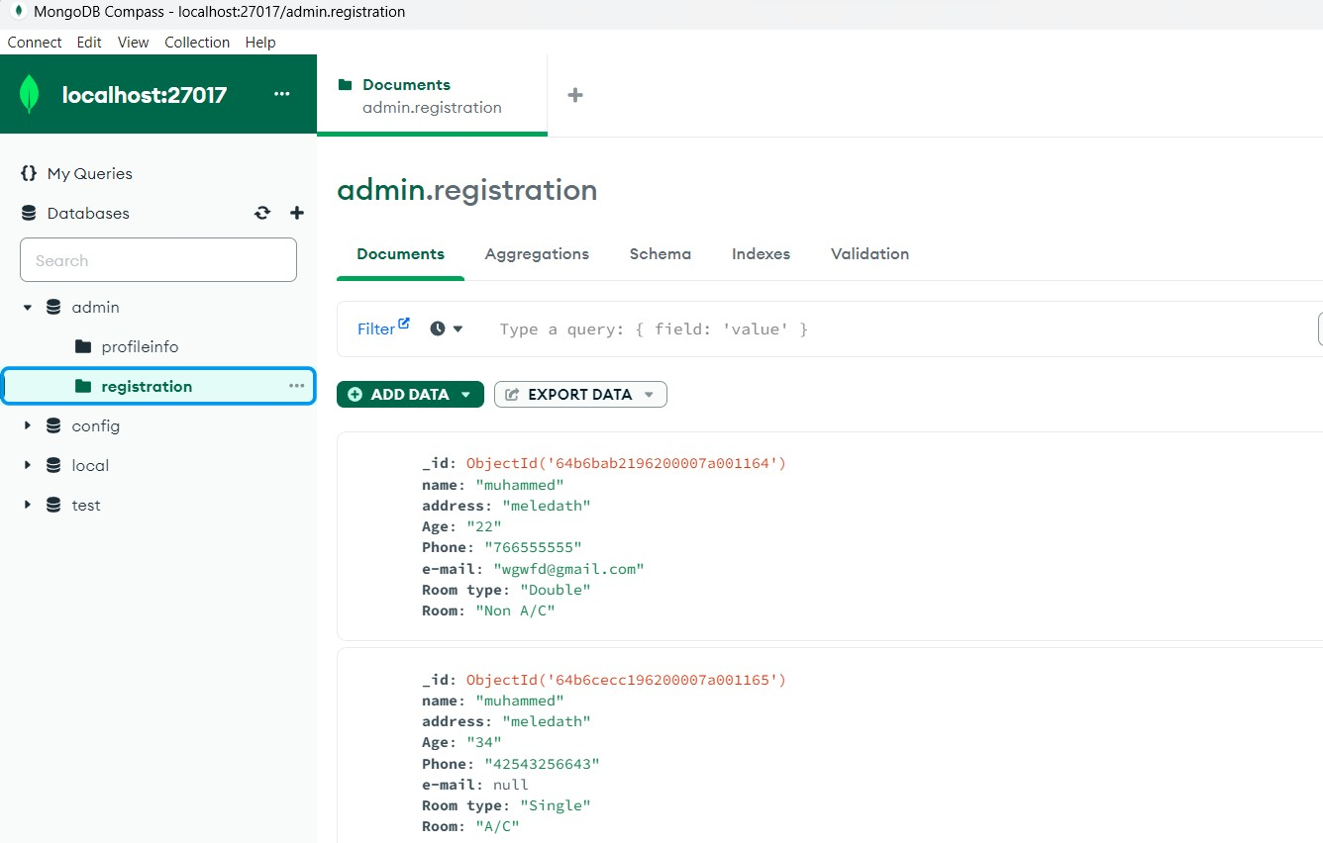

**Result**

The program was executed and the result was successfully obtained. Thus CO4 was obtained